2. Setup a Jenkins CICD pipeline using Declarative pipeline using feature-1.1 branch. https://github.com/betawins/sabear_simplecutomerapp/tree/feature-1.1
stages:
Git Clone
SonarQube Integration
Maven Compilation
Nexus Artifactory
Slack Notification
Deploy On tomcat
STEP 1: Jenkins Prerequisites
1.Install required Jenkins plugins
In Jenkins → Manage Jenkins → Plugins → Available, install:
Git
Pipeline
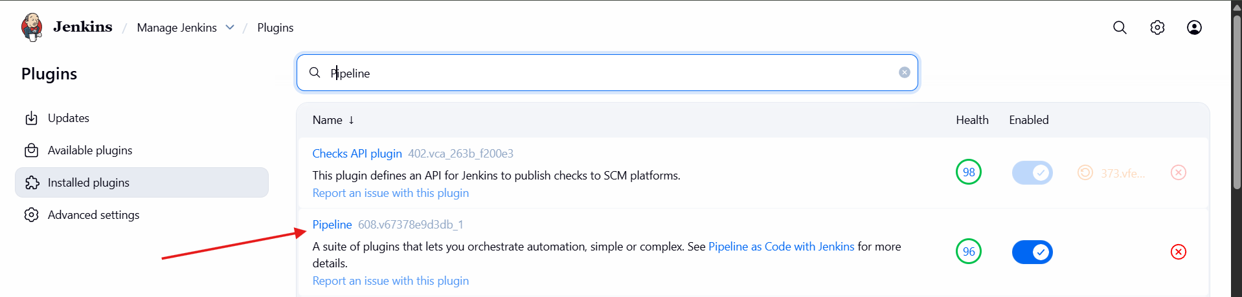
Maven Integration
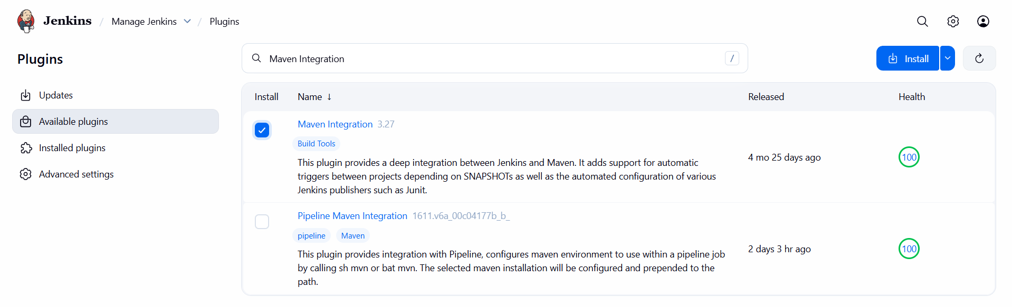
SonarQube Scanner
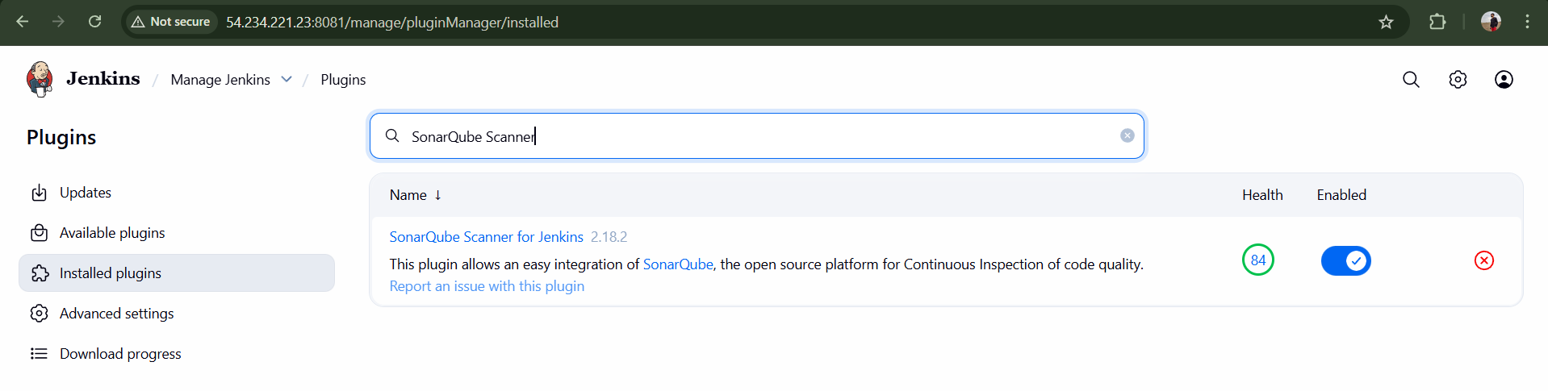
Nexus Artifact Uploader
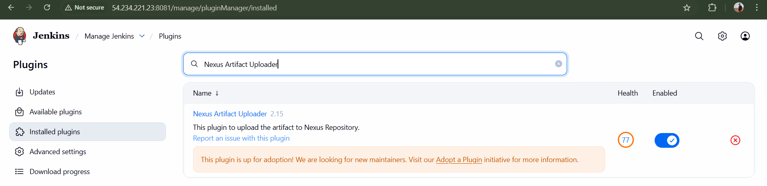
Deploy to container
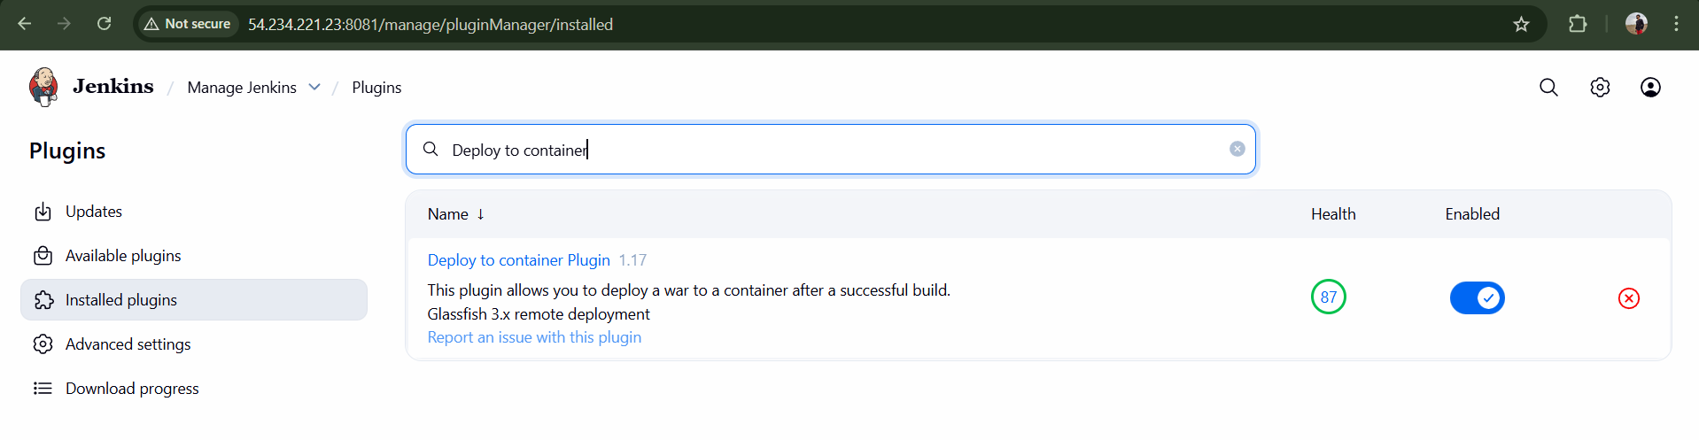
Slack Notification
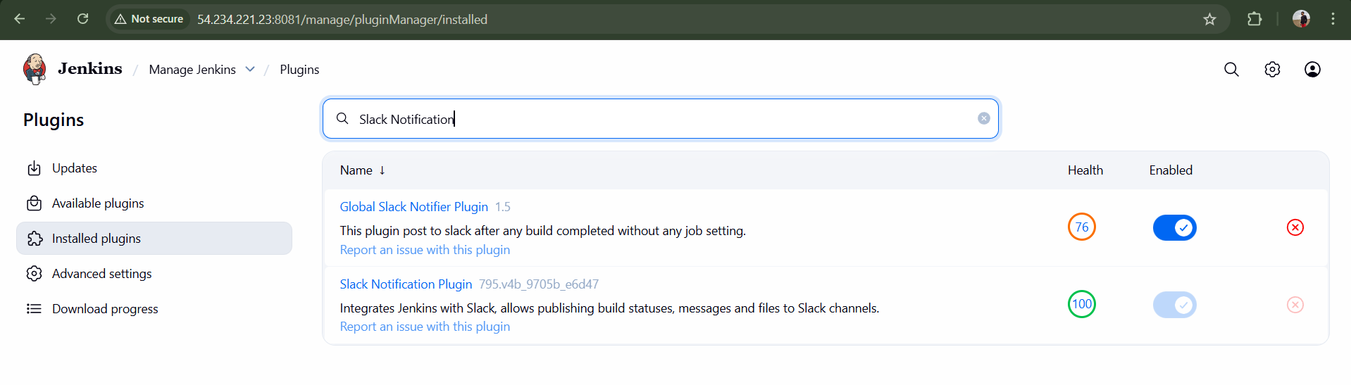
Restart Jenkins after installation.

1. Configure Tools in Jenkins
Maven
Manage Jenkins → Tools → Maven
Name: MVN_HOME
MAVEN_HOME: /opt/apache-maven-3.9.12
Version: Maven 3.x

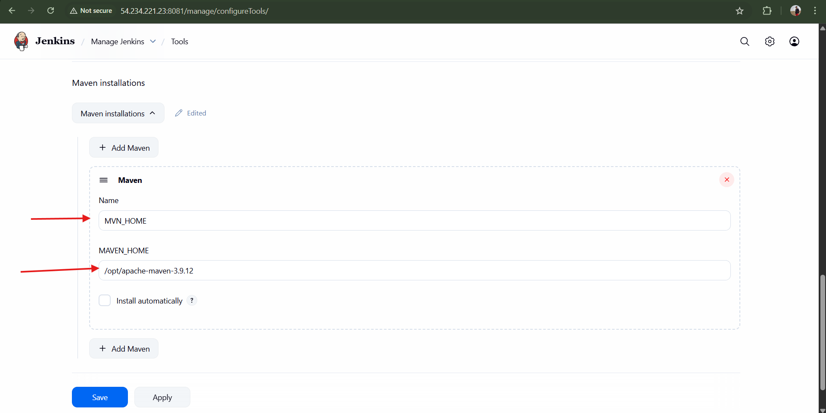
STEP 2: Configure SonarQube in Jenkins
2.Generate SonarQube Token
In SonarQube UI:
Administration → Security → Users → Tokens
Name: sonarqube-token
Copy the token
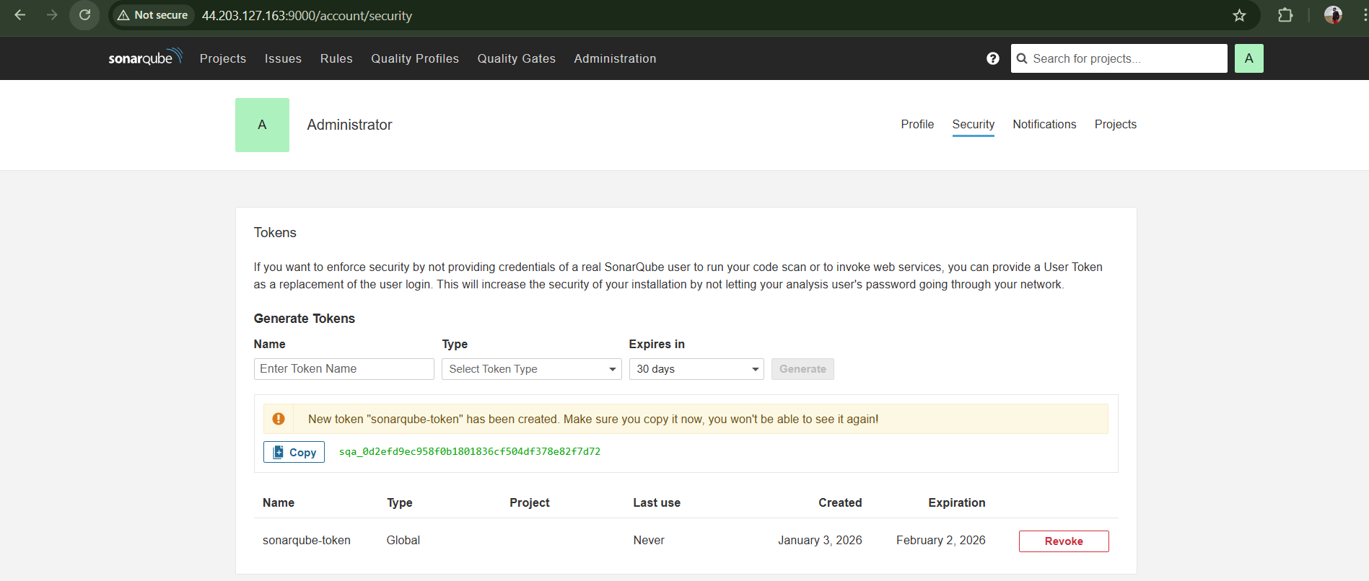
2.2 Add SonarQube token to Jenkins
Manage Jenkins → Credentials → Global → Add Credentials
Kind: Secret Text
ID: sonarqube-token
Secret: (paste token)
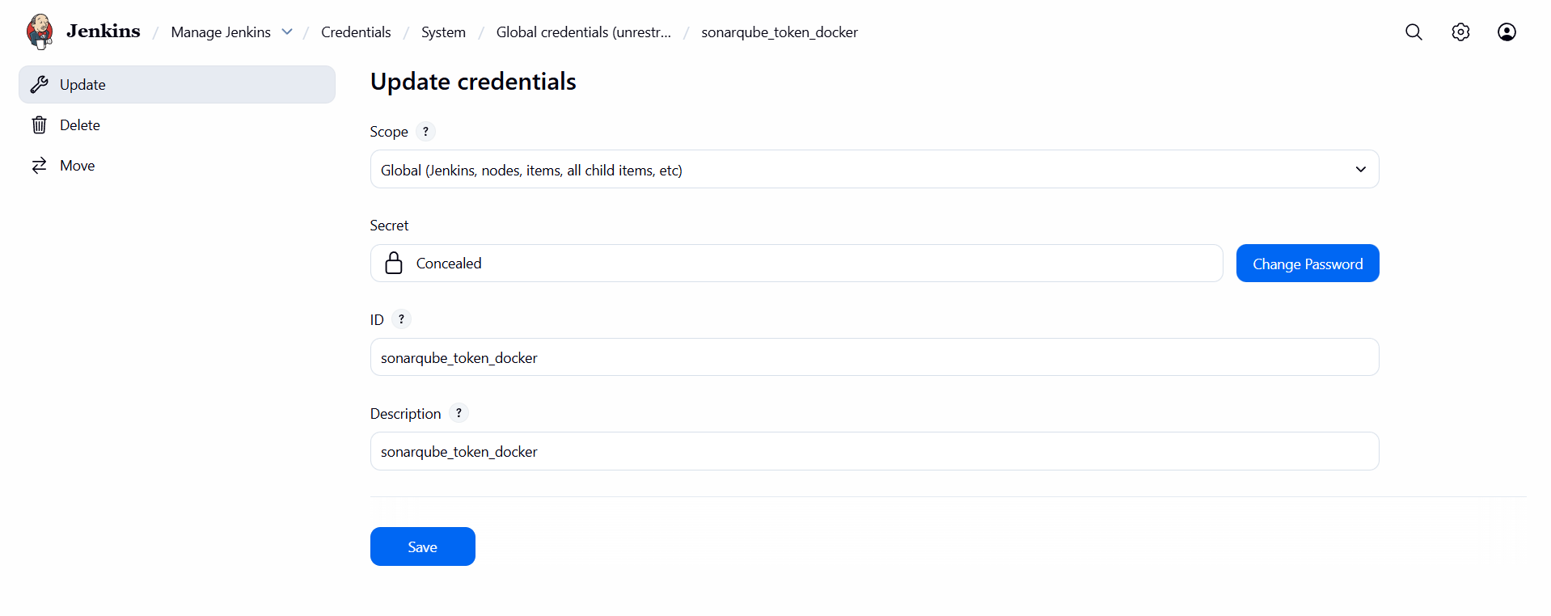
2. Configure SonarQube Server
Manage Jenkins → Configure System → SonarQube
Name: SonarQube-Server
Server URL: http://<sonarqube-ip>:9000
Authentication Token: sonarqube-token
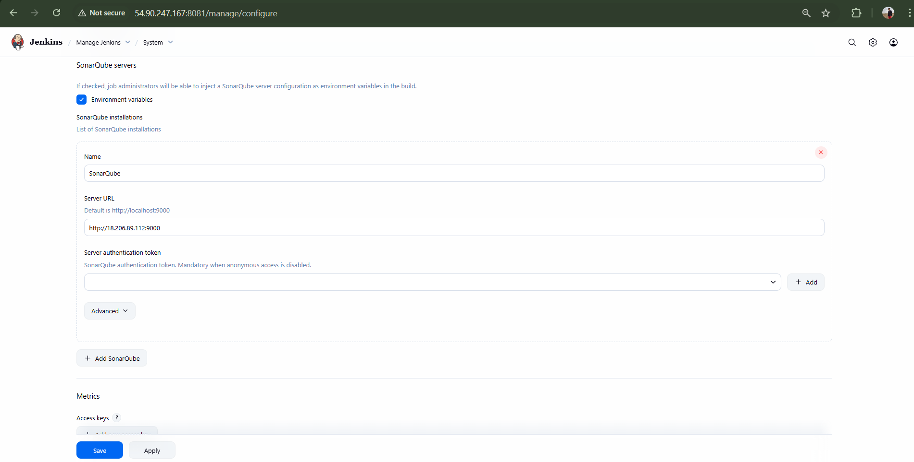
STEP 3: Configure Nexus
3. Add Nexus credentials
Credentials → Global → Add
Kind: Username/Password
ID: nexus-creds
Username: admin
Password: nexus123
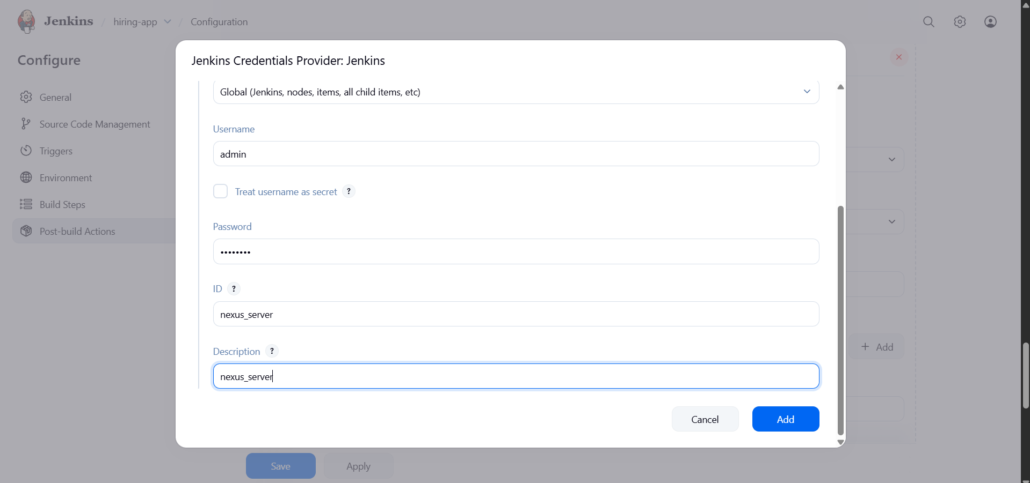
3.Nexus repository info
Repository: SimpleCustomerApp
Nexus URL: http://<nexus-ip>:8081
Create Nexus Repository
In Nexus UI:
Type: maven2 (hosted)
Name: SimpleCustomerApp
Version policy: Snapshot
Layout: Default
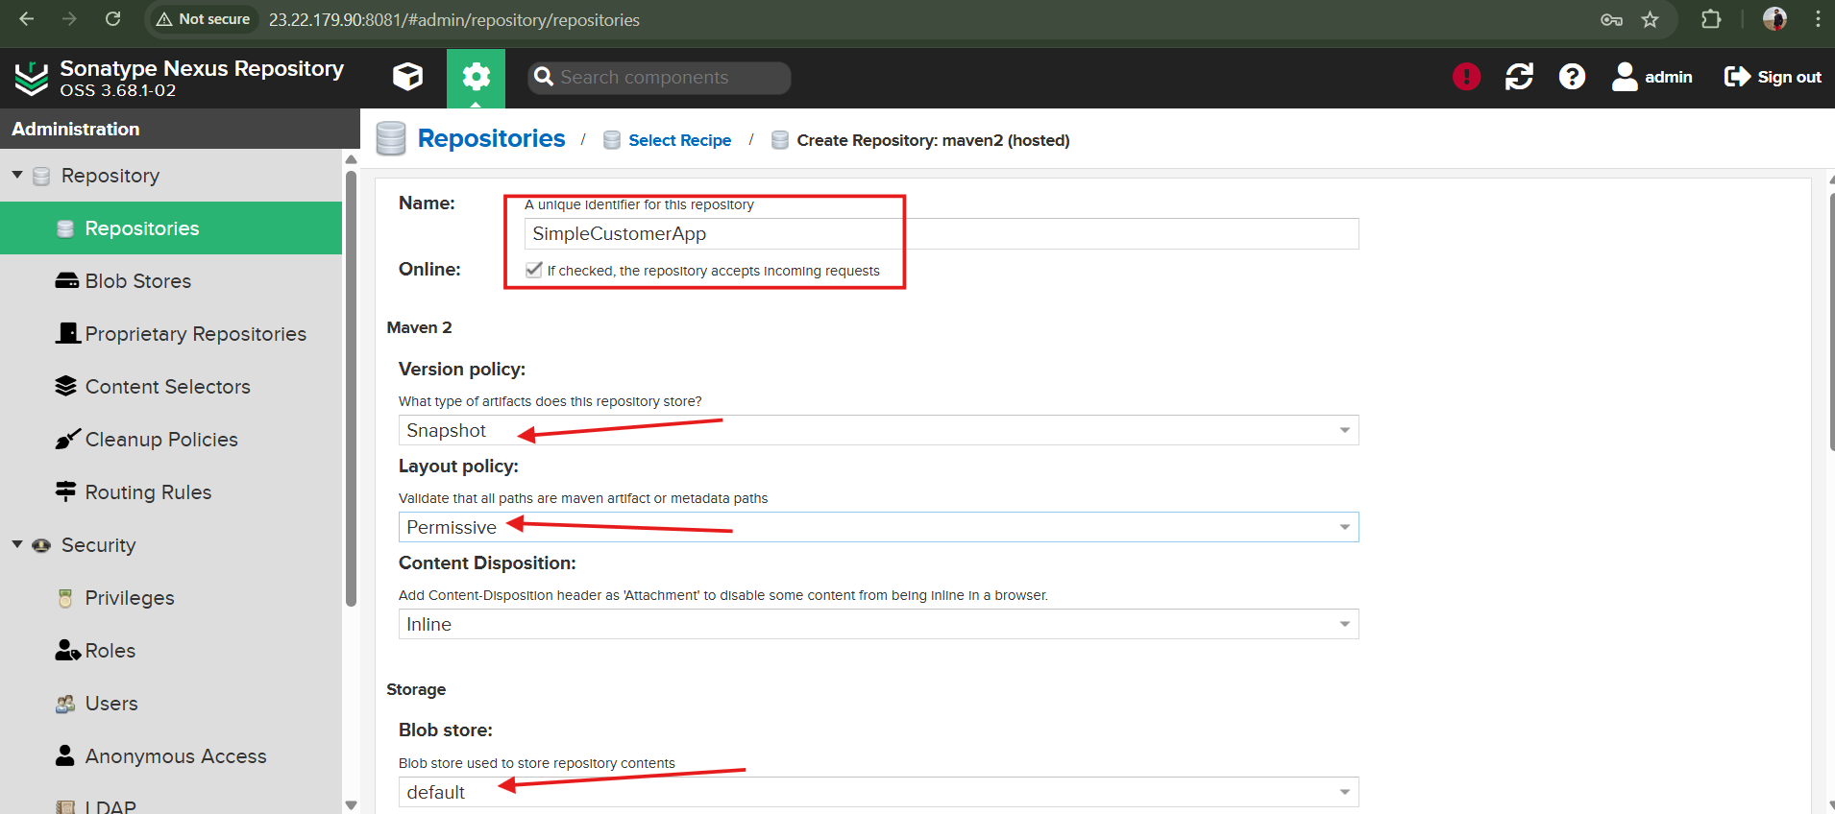
STEP 4: Configure Slack
4. Jenkins → Slack setup
Manage Jenkins → Configure System → Slack
Workspace: TechieHorizon
Channel: #jenkins-integration
Credential: Slack token
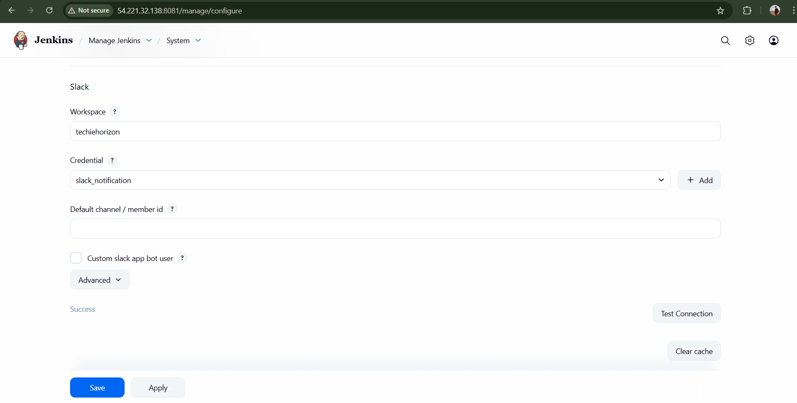
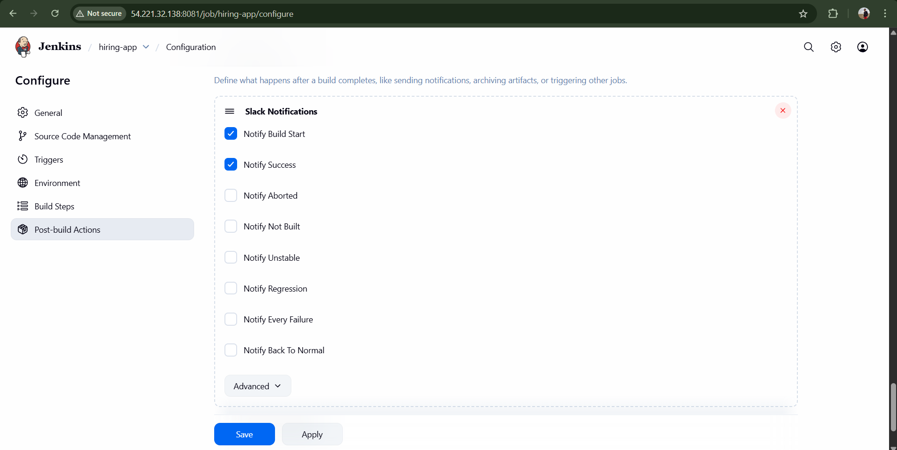
STEP 5: Configure Tomcat
5.1 Create Tomcat user
In tomcat-users.xml:
<role rolename="manager-script"/>
<user username="tomcat" password="tomcat123" roles="manager-script"/>
5.2 Add Tomcat credentials in Jenkins
Kind: Username/Password
ID: tomcat-creds

🔹 STEP 6: Create Jenkins Pipeline Job
Jenkins → New Item
Name: SimpleCustomerApp-CICD
Type: Pipeline

STEP 7: Jenkinsfile (Declarative Pipeline)
pipeline {
agent any
options {
timestamps()
}
environment {
MAVEN_HOME = '/opt/apache-maven-3.9.12'
PATH = "${MAVEN_HOME}/bin:${env.PATH}"

SONAR_PROJECT_KEY = 'SimpleCustomerApp'
SONAR_PROJECT_NAME = 'SimpleCustomerApp'

NEXUS_URL = '23.22.179.90:8081'
NEXUS_REPOSITORY = 'SimpleCustomerApp'
NEXUS_VERSION = 'nexus3'
NEXUS_PROTOCOL = 'http'

TOMCAT_URL = 'http://54.227.155.175:8080'
}

stages {
stage('Notify Started') {
steps {
slackSend(
botUser: true,
color: '#439FE0',
message: "${env.JOB_NAME} - #${env.BUILD_NUMBER} Started (<${env.BUILD_URL}|Open>)"
)
}
}

stage('Git Clone') {
steps {
git 'https://github.com/betawins/sabear_simplecutomerapp.git'
}
}

stage('SonarQube Analysis') {
steps {
withSonarQubeEnv('sonarqube-server') {
sh '''
mvn clean verify \
org.sonarsource.scanner.maven:sonar-maven-plugin:sonar \
-Dsonar.projectKey=${SONAR_PROJECT_KEY} \
-Dsonar.projectName=${SONAR_PROJECT_NAME}
'''
}
}
}

stage('Maven Build') {
steps {
sh 'mvn clean package -DskipTests'
}
}

stage('Nexus Upload') {
steps {
script {
def WAR_FILE = sh(
script: "ls target/*.war",
returnStdout: true
).trim()

nexusArtifactUploader(
nexusVersion: NEXUS_VERSION,
protocol: NEXUS_PROTOCOL,
nexusUrl: NEXUS_URL,
repository: NEXUS_REPOSITORY,
credentialsId: 'NEXUS_SERVER',
groupId: 'com.javatpoint',
version: "${BUILD_NUMBER}-SNAPSHOT",
artifacts: [[
artifactId: 'SimpleCustomerApp',
classifier: '',
type: 'war',
file: WAR_FILE
]]
)
}
}
}

stage('Deploy to Tomcat') {
steps {
deploy adapters: [
tomcat9(
credentialsId: 'tomcat_credentials',
url: "${TOMCAT_URL}"
)
],
contextPath: 'SimpleCustomerApp',
war: 'target/*.war'
}
}
}

post {
success {
slackSend(
botUser: true,
color: 'good',
message: "${env.JOB_NAME} - #${env.BUILD_NUMBER} Success (<${env.BUILD_URL}|Open>)"
)
}
failure {
slackSend(
botUser: true,
color: 'danger',
message: "${env.JOB_NAME} - #${env.BUILD_NUMBER} Failed (<${env.BUILD_URL}|Open>)"
)
}
}
}
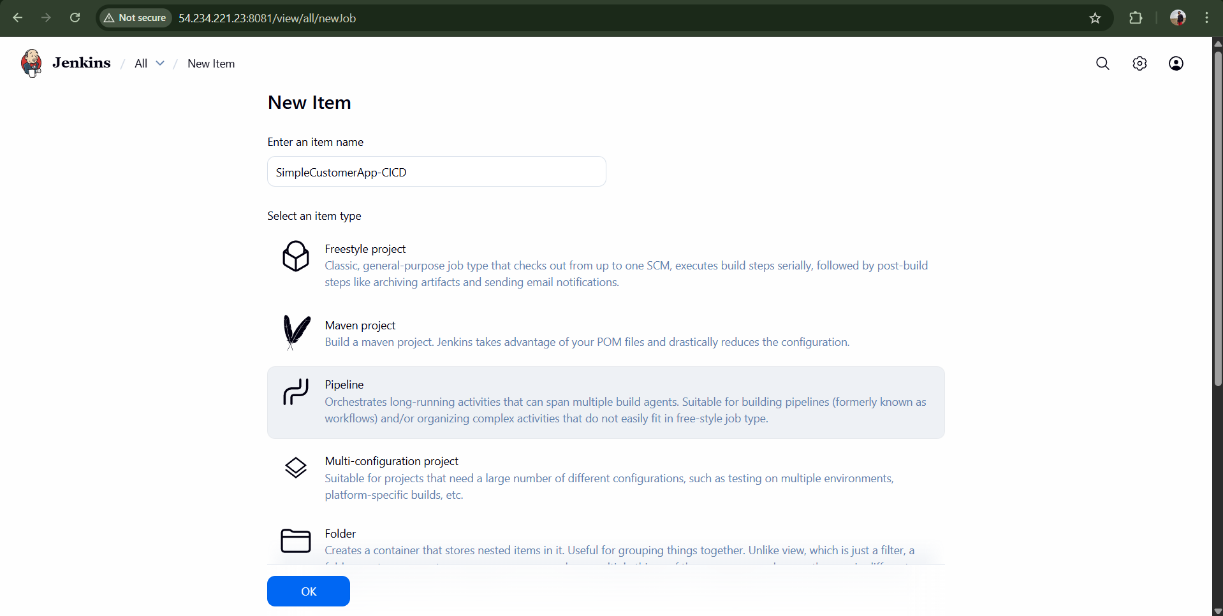
STEP 8: Run & Verify
Click Build Now
Verify:
Git clone from feature-1.1
Git clone: https://github.com/betawins/sabear_simplecutomerapp/tree/feature-1.1
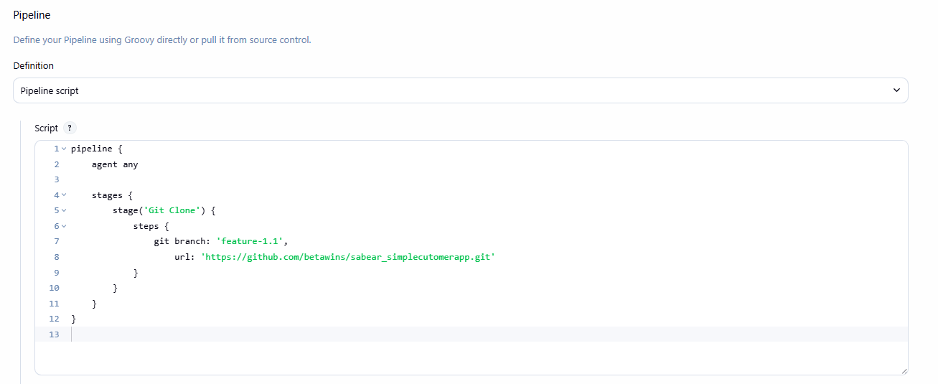
Click Build Now
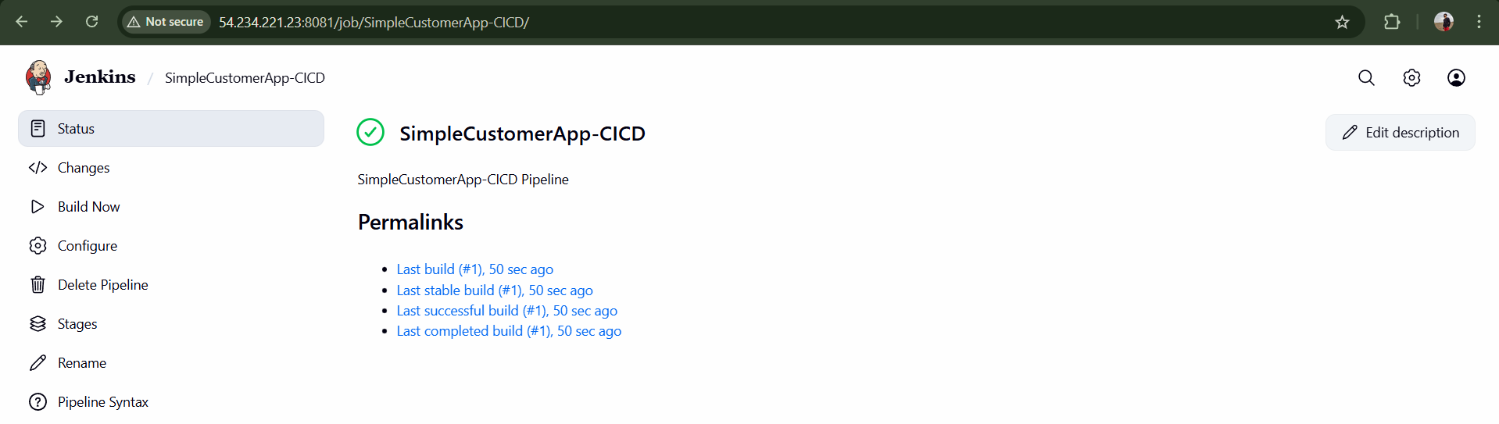
SonarQube report visible
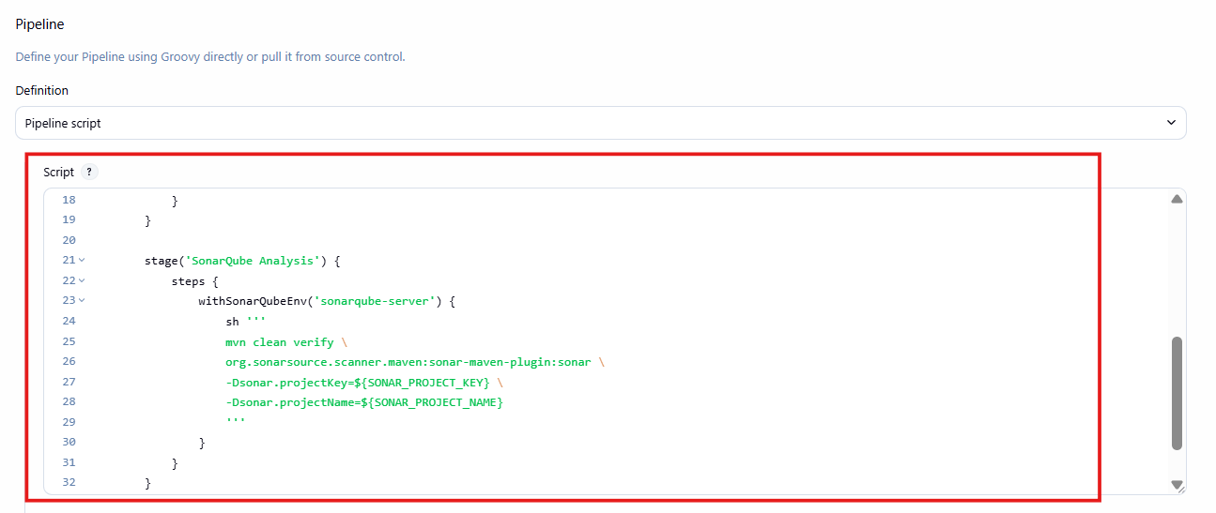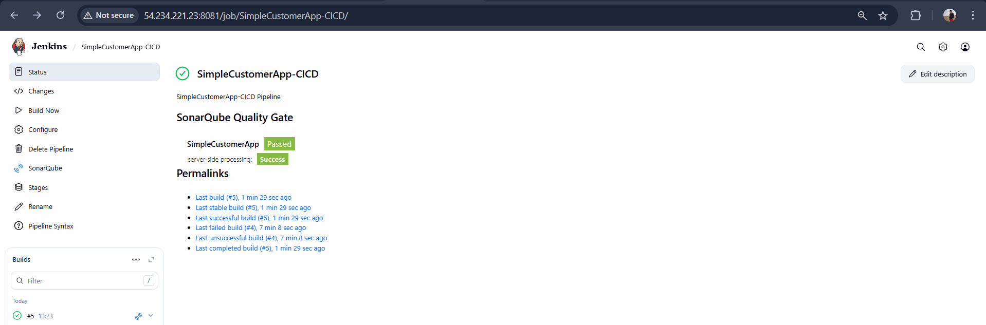
Validation:
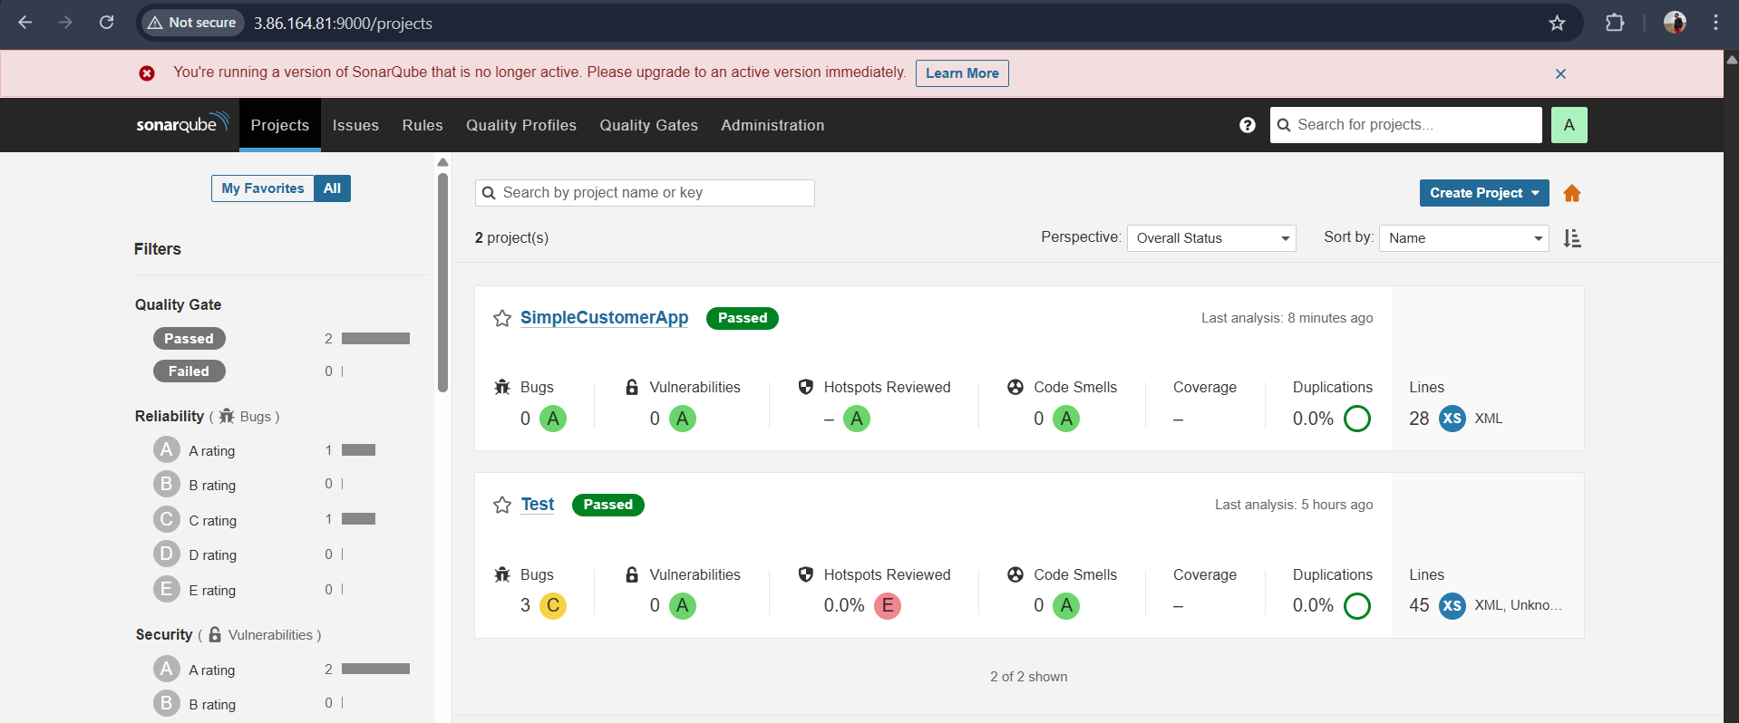
Maven compilation
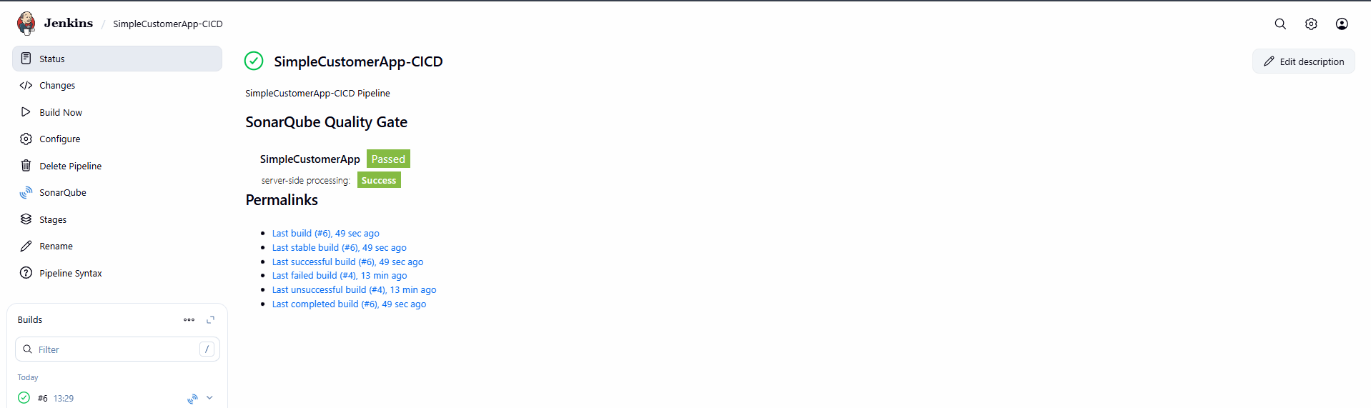
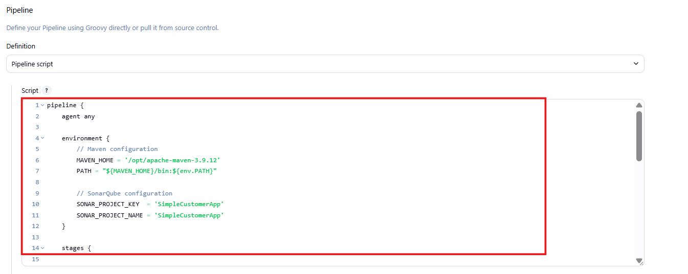
WAR uploaded to Nexus
Create repository in Nexus GUI to store artifacts
- Repository name: SimpleCustomerApp
- Version policy: Snapshot
- Layout policy: Permissive
- Blob store: default
- Deployment policy: Allow redeploy
- Saved repository configuration

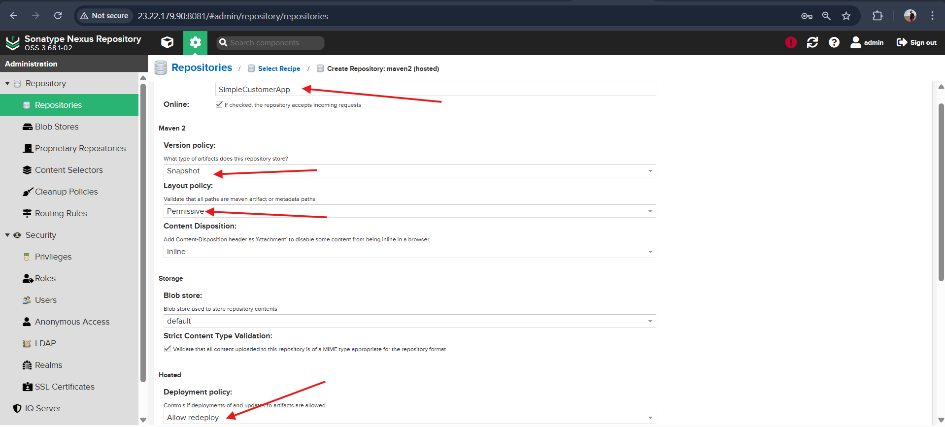
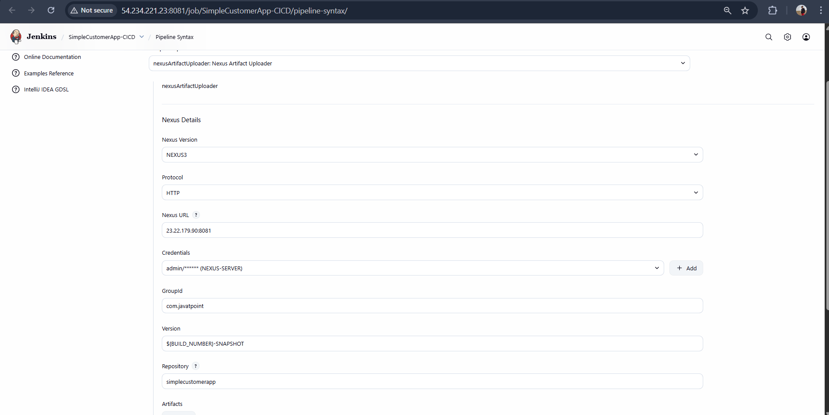
Nexus Artifactory pipeline:
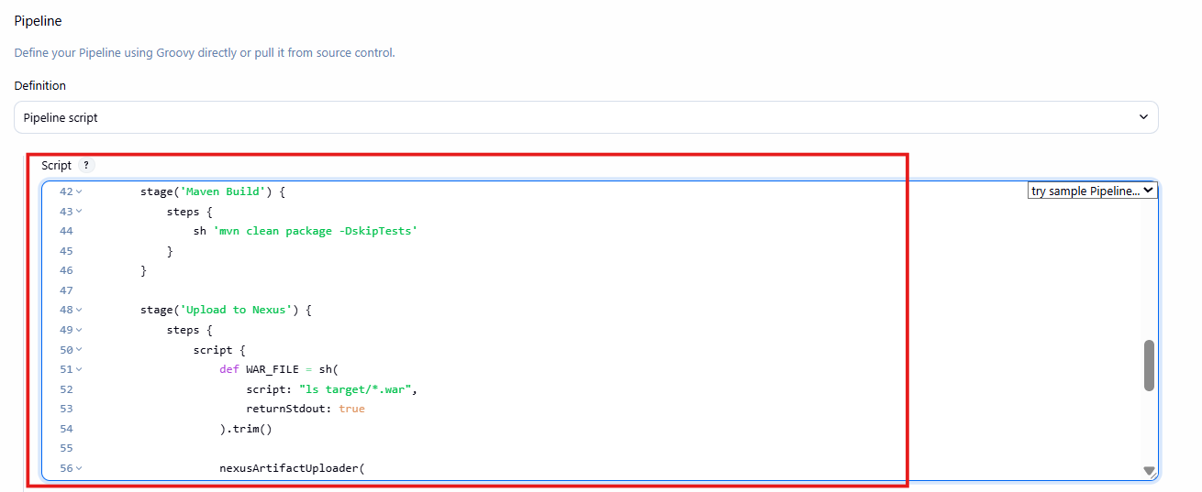
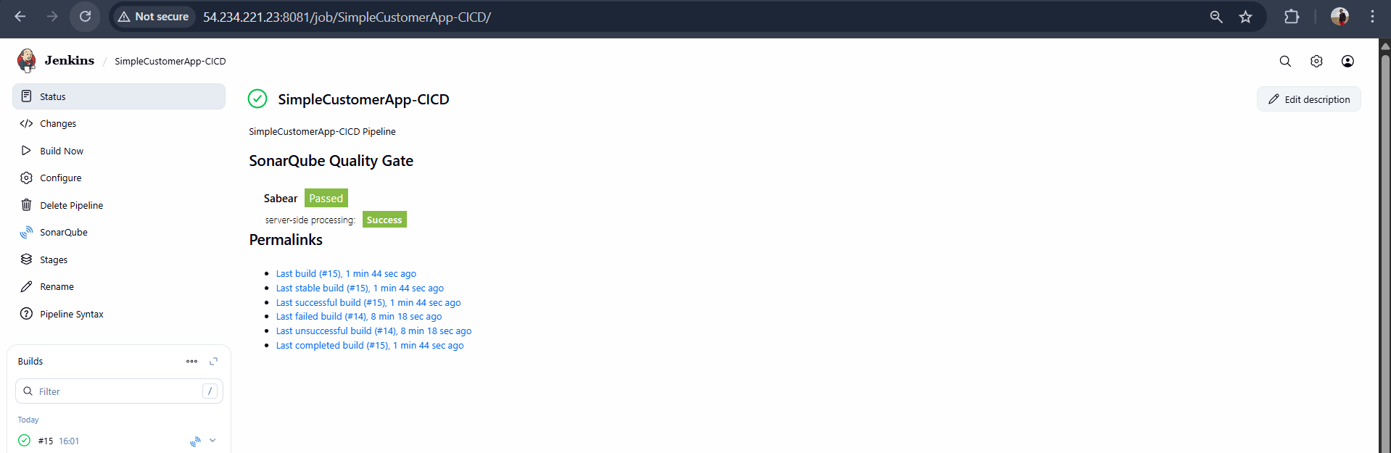

App deployed on Tomcat
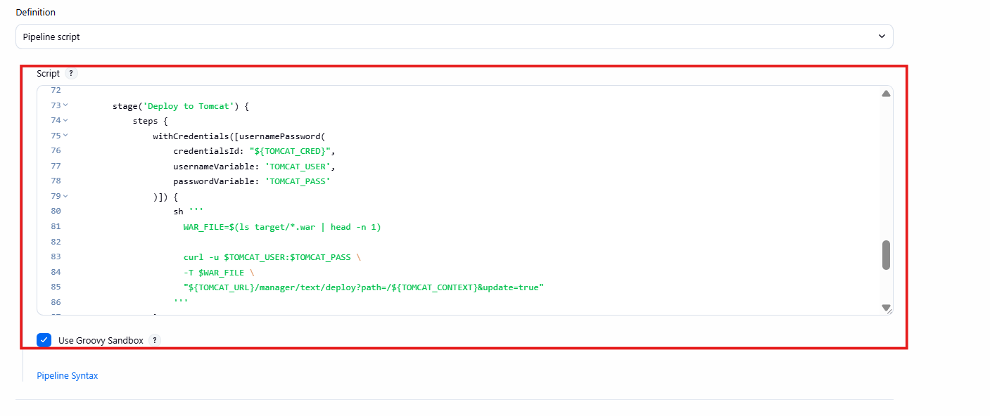

Slack notification received
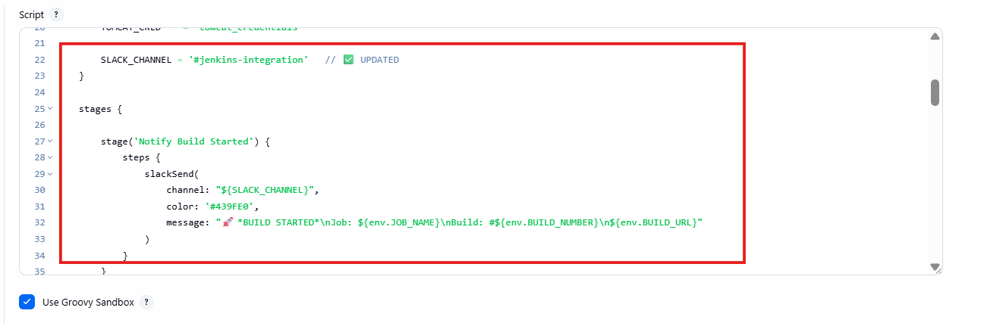
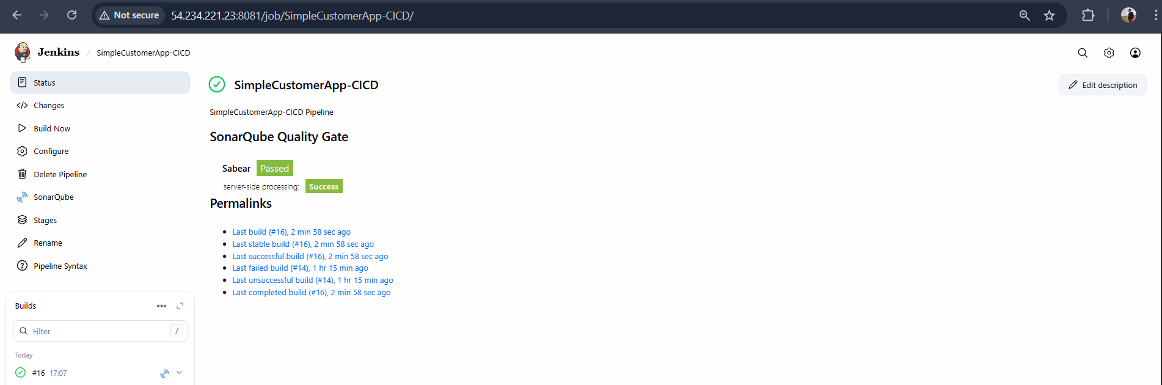
Validation:
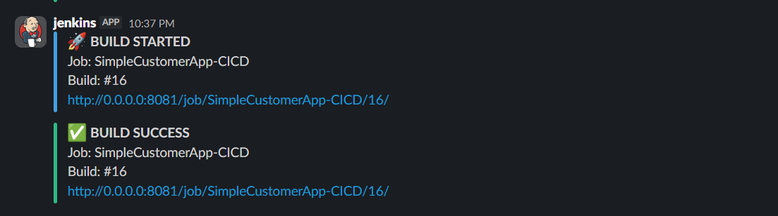

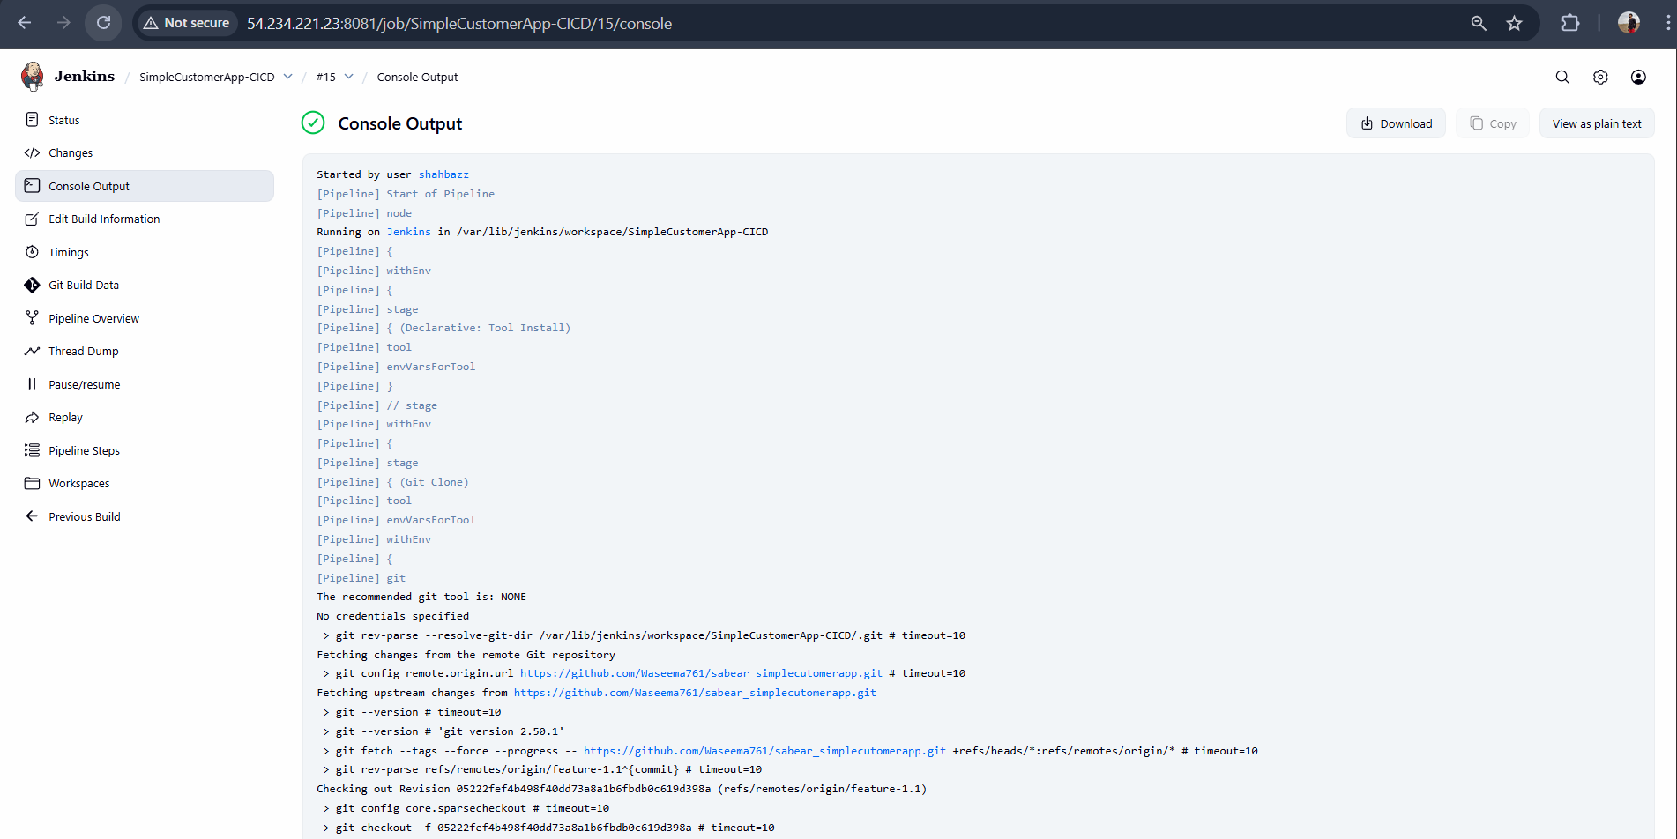
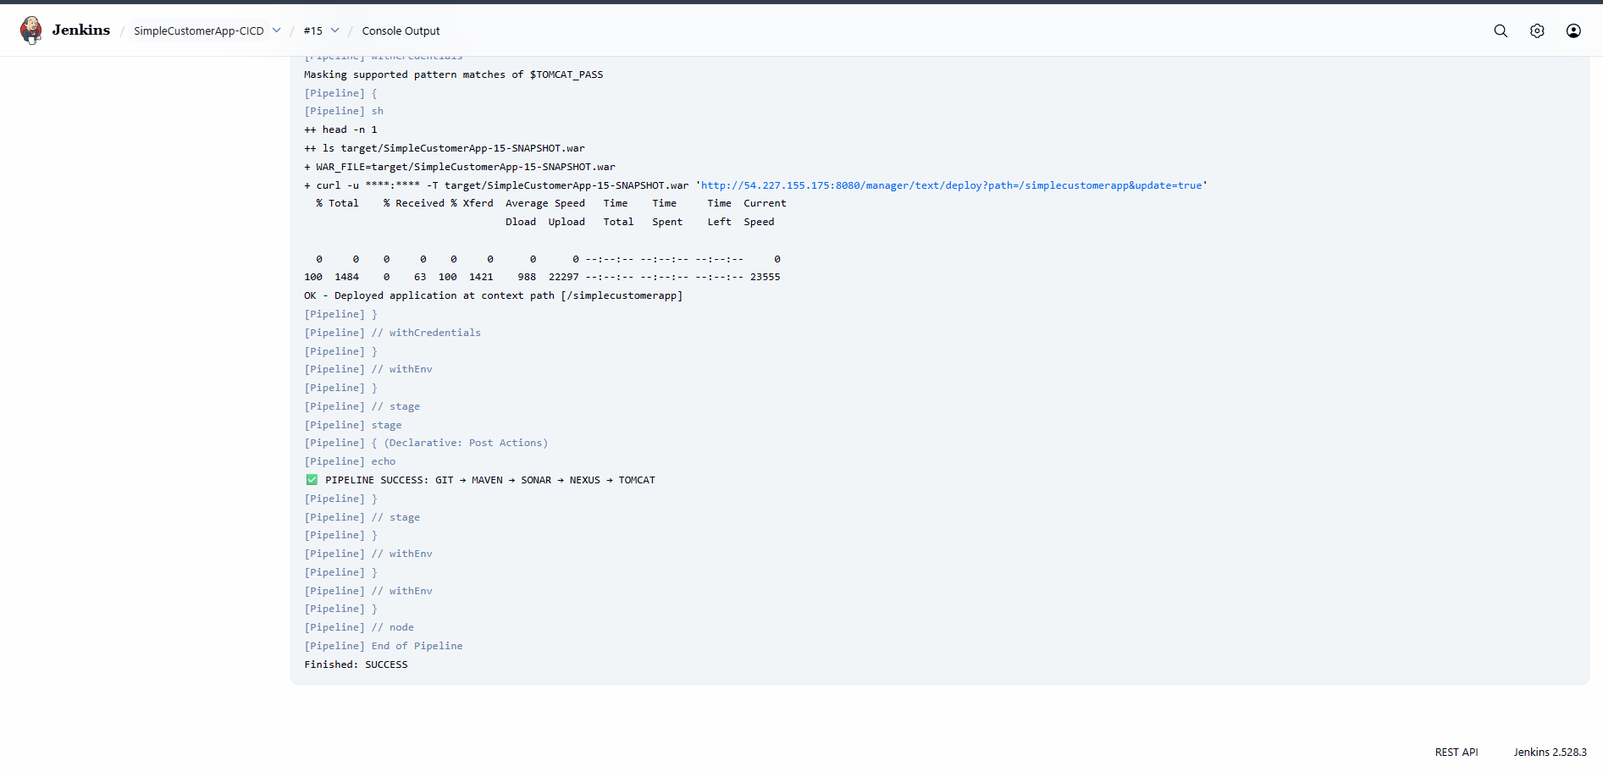
Validation:
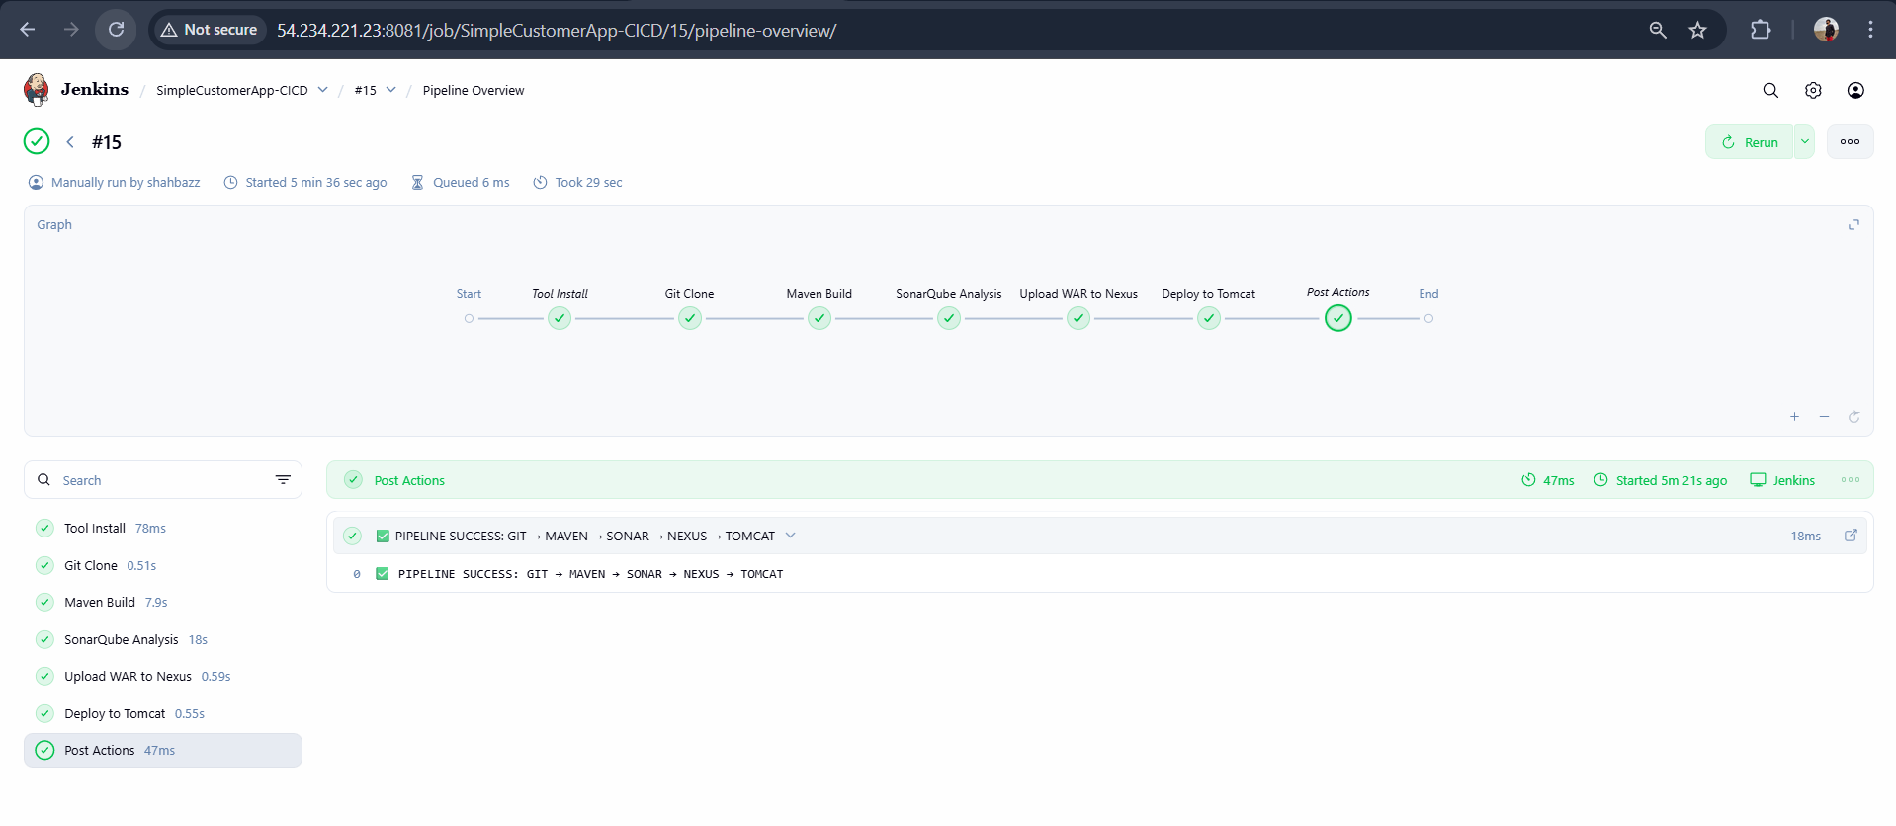
Sonarqube Integration:
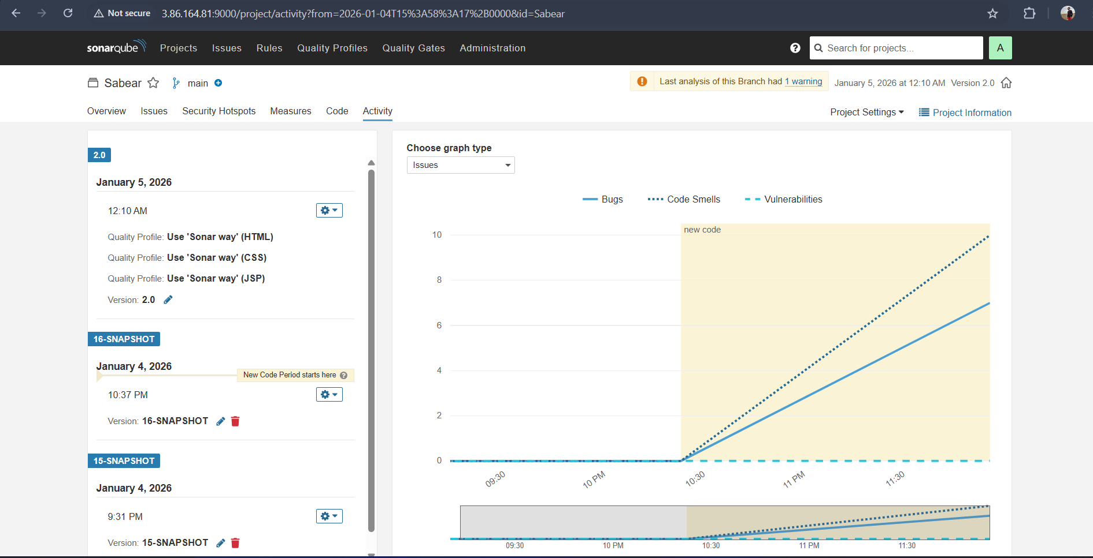
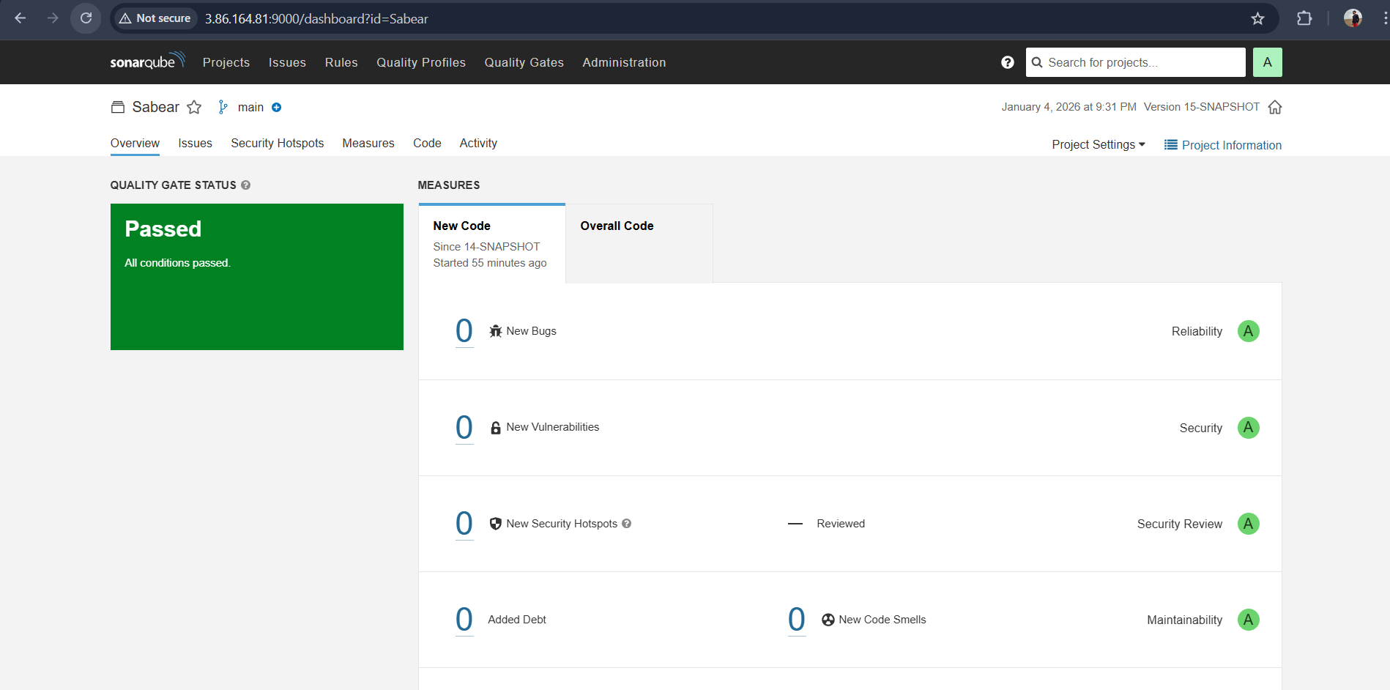

Nexus Artifactory :
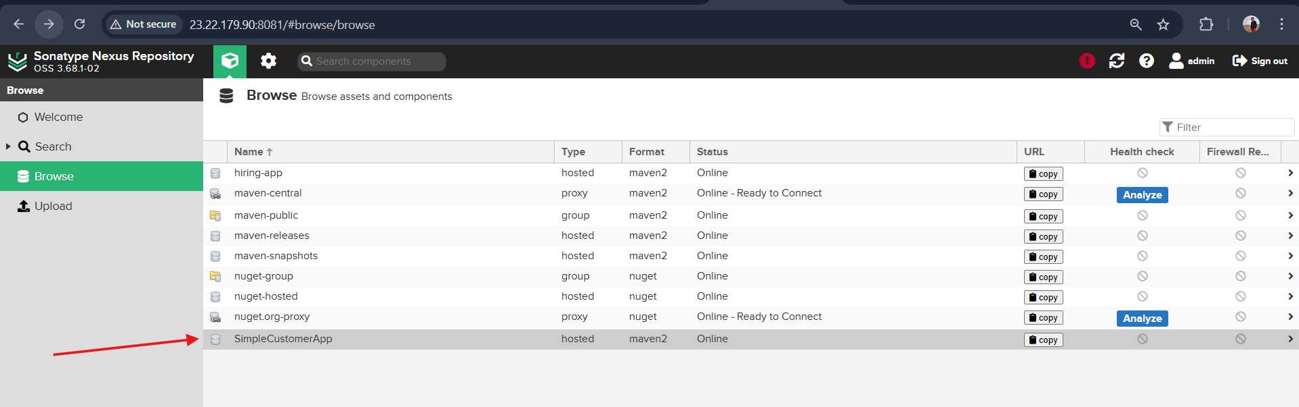

Deploy on tomcat server
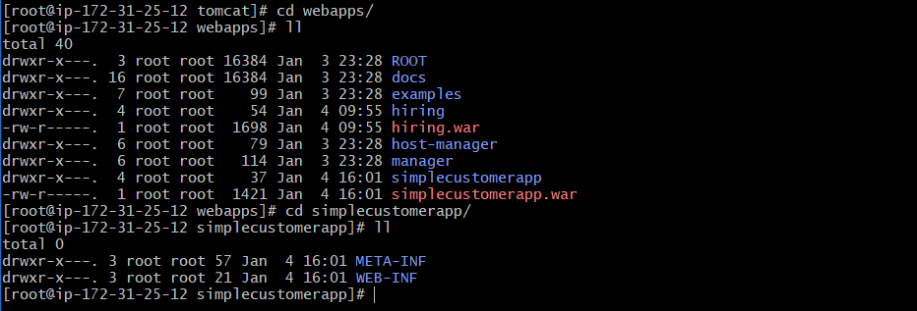
Validate on browser with <public-ip>:8080/simplecustomerapp

